Geometry is nothing if it be not rigorous .... The methods of Euclid are, by almost universal consent, unexceptional in point of rigor

Some critics did not like as an axiom the statement that all right angles are equal and sought to prove it, of course on the basis of the other axioms. Christophorus Clavius (1537-1612), an editor of Euclid's work, noted the absence of an axiom guaranteeing the existence of a fourth proportional to three given magnitudes (Chap. 4, sec. 5). Rightly Leibniz commented that Euclid relied upon intuition when he asserted (Book 1, Proposition 1) that two circles, each of which passes through the center of the other, have a point in common. Euclid assumed, in other words, that a circle is some kind of continuous structure and so must have a point where it is cut by another circle.

Euclidean geometry was supposed to have offered accurate proofs of theorems suggested intuitively by figures, but actually it offered intuitive proofs of accurately drawn figures.

Though criticisms of the logical structure of Euclid's Elements were launched almost from the time it was written, they were not widely known or the defects were regarded as minor. The Elements was generally taken to be the model of rigor. However, the work on non-Euclidean geometry made mathematicians aware of the full extent of the deficiencies in Euclid's structure, for in carrying out proofs they had to be especially critical of what they were accepting. The recognition of the many deficiencies finally obliged the mathematicians to undertake the reconstruction of the foundations of Euclidean geometry and of other geometries that contained the same weaknesses. This activity became extensive in the last third of the nineteenth century.

The work on non-Euclidean geometry had brought the realization that geometries are man-made constructions bearing upon physical space but not necessarily exact idealizations of it. This fact implied that several major changes had to be incorporated in any axiomatic approach to geometry.

Pasch noted that Euclid's common notions, such as point and line, were really not defined. Defining a point as that which has no parts means little, for what is the meaning of parts? In fact, Pasch pointed out, as had Aristotle and a few later mathematicians such as Peacock and Boole, that some concepts must be undefined or else either the process of definition would be unending or mathematics would rest on physical concepts. Once some undefined concepts are selected, others can be defined in terms of these. Thus in geometry point, line, plane (Pasch also used, in his first edition, congruence of line segments) might be chosen as the undefined terms. The choice is not unique. Since there are undefined terms, the question arises as to what properties of these concepts can be used to make proofs about them. The answer given by Pasch is that the axioms make assertions about the undefined terms and these are the only assertions about them that we may use. As Gergonne put it as far back as 1818,4 the undefined concepts are defined implicitly by the axioms.

As for the axioms, Pasch continues, though some may be suggested by experience, once the set is selected it must be possible to execute all proofs without further reference to experience or to the physical meaning of the concepts. Moreover, the axioms are by no means self-evident truths(可能还是受非欧几何的影响吧，所以才会有这种说法) but just assumptions designed to yield the theorems of any particular geometry.
Pasch did believe that the concepts and axioms should bear on experience, but logically this was irrelevant.

Peano gave a set of axioms for Euclidean geometry. He, too, stressed that the basic elements are undefined. He laid down the principle that there should be as few undefined concepts as possible and he used point, segment, and motion.

The following account is taken from the seventh (1930) edition of this book. In his use of undefined concepts and the fact that their properties are specified solely by the axioms, Hilbert follows Pasch. No explicit meaning need be assigned to the undefined concepts. These elements, point, line, plane, and others, could be replaced, as Hilbert put it, by tables, chairs, beer mugs, or other objects. Of course, if geometry deals with "things," the axioms are certainly not self-evident truths but must be regarded as arbitrary even though, in fact, they are suggested by experience.

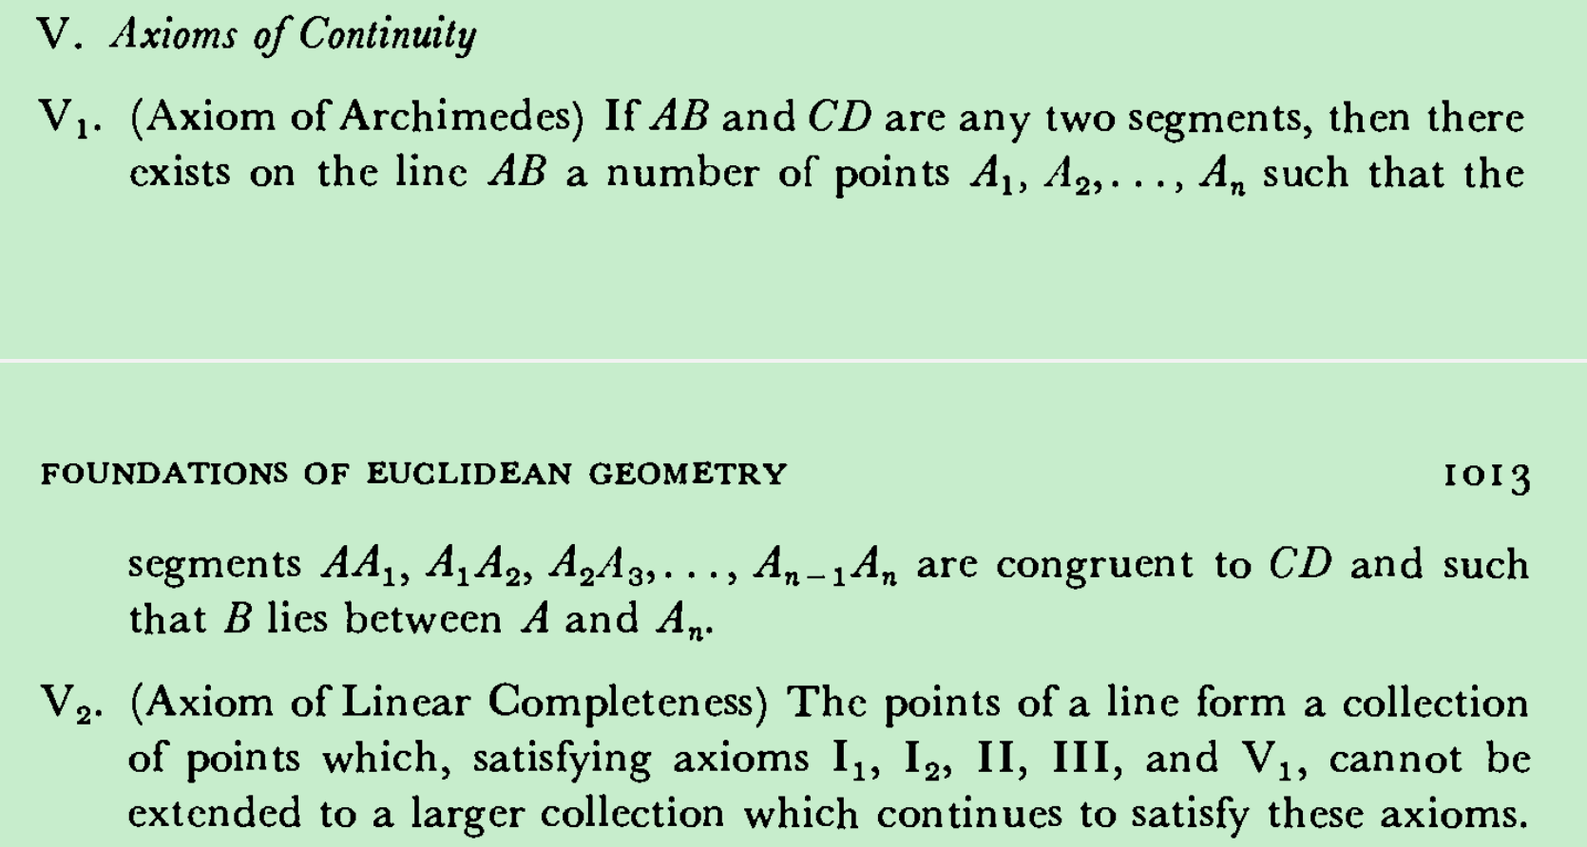
Dedekind's Continuity Axiom是否可以导出二者？等价吗？
This axiom amounts to requiring enough points on the line so that the points can be put into one-to-one correspondence with the real numbers. Though this fact had been used consciously and unconsciously since the days of coordinate geometry, the logical basis for it had not previously been stated.

The arbitrary character of the axioms of Euclidean geometry, that is, their independence of physical reality, brought to the fore another problem, the consistency of this geometry. As long as Euclidean geometry was regarded as the truth about physical space, any doubt about its consistency seemed pointless（默认基于现实就没有矛盾？）. But the new understanding of the undefined concepts and axioms required that the consistency be established（非欧几何的影响）. The problem was all the more vital because the consistency of the non-Euclidean geometries had been reduced to that of Euclidean geometry (Chap. 38, sec. 4). Poincare brought this matter up in 1898 and said that we could believe in the consistency of an axiomatically grounded structure if we could give it an arithmetic interpretation. Hilbert proceeded to show that Euclidean geometry is consistent by supplying such an interpretation.

After every concept has been interpreted arithmetically and it is clear that the axioms are satisfied by the interpretation, Hilbert's argument is that the theorems must also apply to the interpretation because they are logical consequences of the axioms. If there were a contradiction in Euclidean geometry, then the same would hold of the algebraic formulation of geometry, which is an extension of arithmetic. Hence if arithmetic is consistent, so is Euclidean geometry. The consistency of arithmetic remained open at this time (see Chap. 51).

It is desirable to show that no one of the axioms can be deduced from some or all of the others of a given set, for if it can be deduced there is no need to include it as an axiom. This notion of independence was brought up and discussed by Peano in the 1894 paper already referred to, and even earlier in his Arithmetices Principia (1889). Hilbert considered the independence of his axioms. However, it is not possible in his system to show that each axiom is independent of all the others because the meaning of some of them depends upon preceding ones. What Hilbert did succeed in showing was that all the axioms of any one group cannot be deduced from the axioms of the other four groups. His method was to give consistent interpretations or models that satisfy the axioms of four groups but do not satisfy all the axioms of the fifth group.
The proofs of independence have a special bearing on non-Euclidean geometry. To establish the independence of the parallel axiom, Hilbert gave a model that satisfies the other four groups of axioms but docs not satisfy the Euclidean parallel axiom. His model uses the points interior to a Euclidean sphere and special transformations which take the boundary of the sphere into itself. Hence the parallel axiom cannot be a consequence of the other four groups because if it were, the model as a part of Euclidean geometry would possess contradictory properties on parallelism. This same proof shows that non-Euclidean geometry is possible because if the Euclidean parallel axiom is independent of the other axioms, a denial of this axiom must also be independent; for if it were a consequence, the full set of Euclidean axioms would contain a contradiction.

Hilbert himself, as we have already noted, kept changing his system until he gave the 1930 version. Among the numerous alternative systems we shall mention just one. Vcblcn gave a set of axioms based on the undefined concepts of point and order. He showed that each of his axioms is independent of the others, and he also established another property, namely, categoricalness.

对Hilbert 's axioms的把玩
One of the nice features of Hilbert’s axioms is that the axioms for hyperbolic non-Euclidean geometry are obtained at once by replacing the Euclidean parallel axiom by the Lobatchcvsky-Bolyai axiom.

To obtain axioms for either single or double elliptic geometry, one must not only abandon the Euclidean parallel axiom in favor of an axiom to the effect that any two lines have one point in common (single elliptic) or at least one in common (double elliptic), but one must also change other axioms.

Another class of investigations in the foundations of geometry is to consider the consequences of denying or just omitting one or more of a set of axioms. Hilbert in his independence proofs had done this himself, for the essence of such a proof is to construct a model or interpretation that satisfies all of the axioms except the one whose independence is to be established. The most significant example of an axiom that was denied is, of course, the parallel axiom. Interesting results have come from dropping the axiom of Archimedes, which can be stated as in Hilbert's V1. The resulting geometry is called non-Archimedean; in it there are segments such that the multiple of one by any whole number, however large, need not exceed another. In Fondamenti di geometria, Giuseppe Veronese constructed such a geometry. He also showed that the theorems of this geometry approximate as closely as one wishes those of Euclidean geometry.

-------
The foundation of Euclidean gcometry was approached in an entirely different manner by some mathematicians. **Geometry, as we know, had fallen into disfavor because mathematicians found that they had unconsciously accepted facts on an intuitive basis, and their supposed proofs were consequently incomplete. The danger that this would continually recur made them believe that the only sound basis for geometry would be arithmetic.** The way to erect such a basis was clear. In fact, Hilbert had given an arithmetic interpretation of Euclidean geometry. **What had to be done now, for plane geometry say, was not to interpret point as the pair of numbers $(x, y)$ but to define point to be the pair of numbers, to define a line as a ratio of three numbers $(u: v: w)$, to define the point $(x, y)$ as being on the line $(u, v, w)$ if and only if $u x+v y+w=0$, to define circle as the set of all $(x, y)$ satisfying the equation $(x-a)^2+(y-b)^2=r^2$, and so on**. In other words, one would use the analytic geometry equivalents of purely geometric notions as the definitions of the geometrical concepts and algebraic methods to prove theorems. Since analytic geometry contains in algebraic form the complete counterpart of all that exists in Euclidean geometry, there was no question that the arithmetic foundations could be obtained（但问题是arithmetic foundations要如何建立？如何更好地建立？）. Actually the technical work involved had really been done, even for $n$-dimensional Euclidean geometry, for example by Grassmann in his Calculus of Extension; and Grassmann himself proposed that this work serve as the foundation for Euclidean geometry.

The question of what is meant by a curve remained open. Felix Klein remarked in 1898 that nothing was more obscure than the notion of a curve. This question was taken up by the topologists (Chap. 50, sec. 2).

Beyond the problem of what is meant by a curve, the extension of analysis to functions without derivatives also raised the question of what is meant by the length of a curve. The usual calculus formula
\[
L=\int_a^b\left(\mathrm{I}+y^2\right)^{1 / 2} d x,
\]
where $y=f(x)$, calls, at the very least, for the existence of the derivative. Hence, the concept no longer applies to the non-differentiable functions. Various efforts to generalize the concept of length of curve were made by Du Bois-Reymond, Peano, Ludwig Scheeffer (1859-85), and Jordan, using either generalized integral definitions or geometric concepts. The most general definition was formulated in terms of the notion of measure, which we shall examine in Chapter 44 .

The theory of surface area was also reconsidered in terms of the notion of measure.

Helge von Koch (1870-1924)33 complicated the area problem by giving an example of a continuous but non-differentiable curve with infinite perimeter which bounds a finite area.
https://en.wikipedia.org/wiki/Koch_snowflake

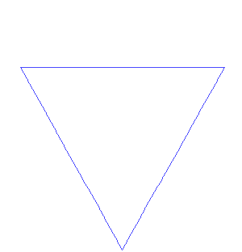
In the light of these difficulties we see that the rigorization of geometry certainly did not answer all the questions that were raised. Many were settled by the topologists and analysts of the next century. The very fact that questions about fundamental concepts continued to arise illustrates once more that mathematics does not grow as a logical structure. Advances into new fields and even the perfection of old ones reveal new and unsuspected defects. Beyond the resolution of the problems involving curves and surfaces we have yet to see whether the ultimate stage in rigor was reached by the foundational work in analysis, the real number system, and basic geometry.

探究这一切主要是为了确定除法n等分那里的基础是不是可以独立于数而严谨建立？

